**Issues:**

**Observation 1:**

Email address field is accepting any random values instead it should accept only valid mail id format for e.g [xxxx@mail.com](mailto:xxxx@mail.com)

**Steps to reproduce:**

* Open <http://bit.ly/dxqatest-online>.
* Click on E-mail field and enter any random value.

**Snapshot:**

Submit enabled even if mail id is not in proper format.

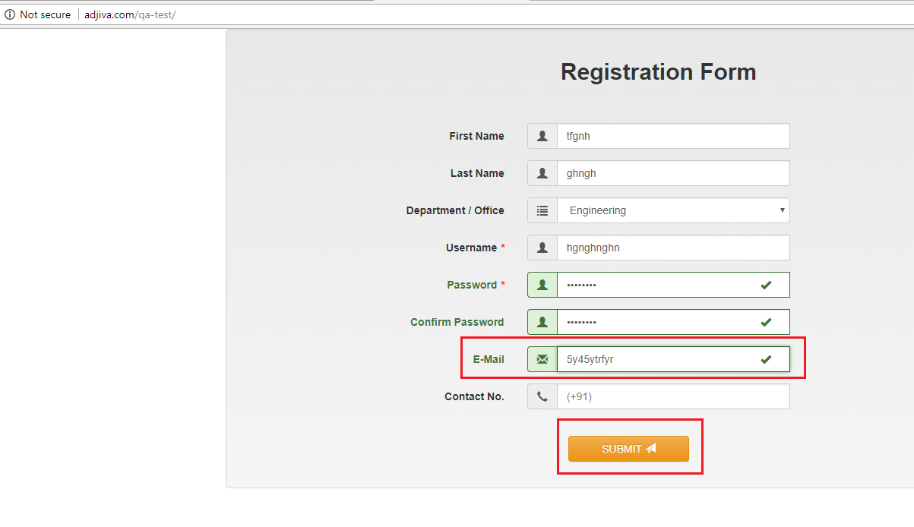

**Observation 2:** Confirm Password filed is not working properly.

Steps to reproduce:

* Open <http://bit.ly/dxqatest-online>.
* Fill required fields.
* In Password field enter any 8 character or 8 numbers e.g. 12345678. It should accept and green tick should appear.
* Now in confirm password field enter 1234567891234.

Actual result: even if confirm password is not matching with password the field is accepting the value and submit button is enabled and user is able to submit the form.

Snapshot:

